**2 Day  Workshop - Full Syllabus**

**Day - 1 (4th Nov 2023)**

**Laying Down the Foundation**

* ***A quick walkthrough of a sample web application architecture diagram***
  1. Visualising the application layers and flow
* ***Understanding performance and role of load testing***
  1. Modern day user’s impatience
  2. Just Functional or User Experience?
  3. Performance and Load testing
* ***Understanding concurrency***
  1. Concurrent users v/s. Users causing concurrency
  2. Load injector POV vs Server POV
* ***A handful of reasons behind low performance***

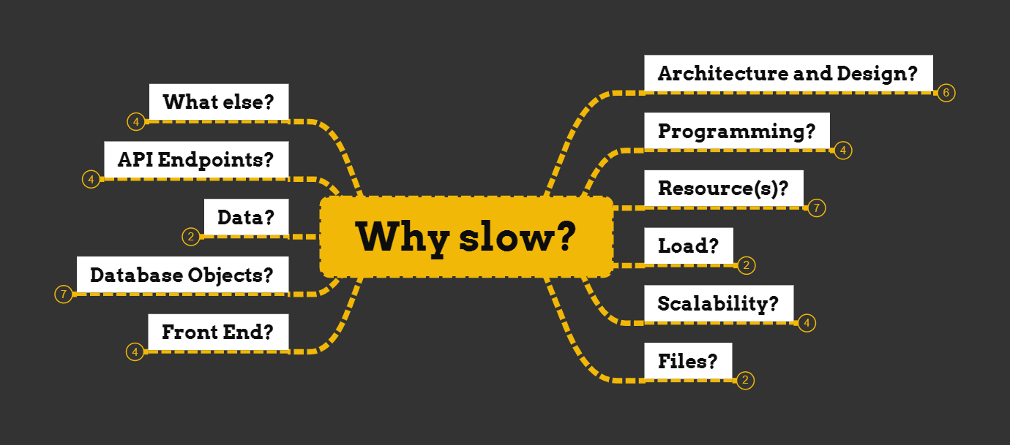

**Exploring Apache Apache JMeter(™)**

* ***Setting up Apache JMeter(™)***
  1. Unarchive & Launch
  2. Quick walkthrough of Apache JMeter(™) GUI
* ***Threads - Simulating virtual users***
  1. Thread group
  2. Open Model Thread Group
* ***Config Element - Configuring users and their requests to the server***
  1. CSV Data Set Config
  2. HTTP Request Defaults
  3. HCC Managers
* ***Timer - Sending requests smartly***
  1. Constant Timer
  2. Uniform Random Timer
  3. More?
* ***Sampler - The user’s requests***
  1. Dummy
  2. Debug
  3. HTTP
  4. JDBC
* **C*ontroller - Customising samplers processing order***
  1. If Controller
  2. Transaction Controller
* ***Assertion - Checking success or failure of a Sample result***
  1. Response
  2. JSON
  3. Size
* ***Listener - Showing results of test execution***
  1. At the time of scripting
  2. At the time of actual load test execution
* ***Pre- and Post-Processors - Before and After making a user request***
  1. JSR223 PreProcessor
  2. JSON Extractor
  3. Boundary Extractor
  4. RegEx Extractor
* ***Homework assignment***

**Day - 2 (5th Nov 2023)**

**Load Test Designing and Planning**

* ***Functions and Variables***
  1. Function Helper
* ***Understanding execution order and scoping rules***
  1. The CO-P-TI-SA-P-A-L mnemonic
* ***Systematically planning and designing load tests***
  1. Requirements and Goals
  2. Test data
  3. Test environment
* ***Quick overview - Prompt engineering to assist in Perf/Load test strategy & planning***
  1. Generate test ideas
  2. Exploring lessons learned
  3. Common mistakes
* ***Apache JMeter(™) -> HTTP Proxy setup + HTTP Test Script Recorder***
  1. Man in the Middle - Proxy
  2. Templates and Recorders - Apache JMeter(™) to capture Traffic
  3. Generating a Web Load Test Plan
* ***Scripting & Debugging a Web (ReST) API Test Plan***
  1. Using cURL
  2. Using Postman Interceptor
* ***Understanding and handling Correlation***
  1. Human intervention-based Correlation
  2. Auto-Correlation

**Load Test Execution**

* ***Load Test Execution***
  1. Validate and Baseline
  2. Command line | parameterized execution
  3. Distributed execution (Optional)
  4. Cloud execution
* ***Measure and Monitor***
  1. Latency
  2. Response Time
  3. Throughput
  4. Standard Deviation
  5. Percentiles / Averages or ?
  6. Errors
  7. CPU, Memory, Database and I/O
* ***Analysis and Reporting***
  1. APDEX
  2. HTML Reports
  3. Test Summary Report
* ***Q&A***

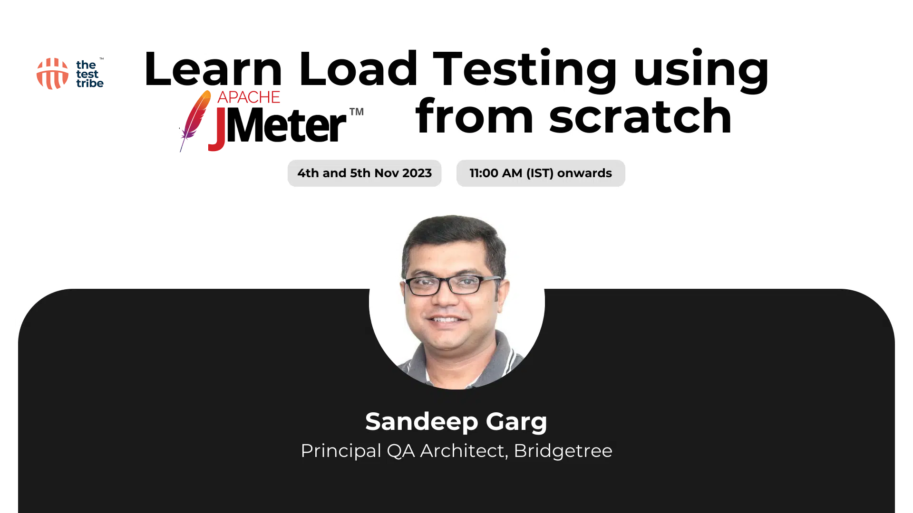

**Register here:** [**https://bit.ly/JMeter_2Days**](https://bit.ly/JMeter_2Days)